##### GUJARAT TECHNOLOGICAL UNIVERSITY

Chandkheda, Ahmedabad Affiliated





**L.J. Institute of Engineering Technology**

A Report On:

# SCHOLAR BINDER

Under subject of

##### DESIGN ENGINEERING – II B

B. E. Semester – VI Information & Communication Technology

|  |  |  |
| --- | --- | --- |
| **Sr No.** | **Name Of Students** | **Enrollment No.** |
| **1** | **Pathan Mahamad Zaidkhan** | **200320132005** |
| **2** | **Patel Raaz Kumar** | **200320132022** |
| **3** | **Rahil M Agharia** | **200320132001** |
| **4** | **Mistry Manav Manishkumar** | **200320132008** |

**Ms. FORAM GOHEL Mr. PRAYAG PATEL**

**(Faculty Guide) (Head of the Department)**

CERTIFICATE

This is certify that project work embodied in this thesis entitled “**SCHOLAR BINDER**” has been carried out by **Patel Raaz Kumar[200320132022], Pathan Mahamad Zaidkhan[200320132005], Rahil M Agaria [200320132001] and Mistry Manav Manishkumar [200320132008]** at **L J INSTITUTE OF ENGINEERING AND**

**TECHNOLOGY AHMEDABAD** for partial

fulfilment of **Bachelor of Engineering Degree** in Information and Communication Technology to be awarded by Gujarat Technological University for **FEB-2023** to **JUNE-2023**. This project work has been carried out under my supervision and is to the satisfaction of department.

DATE:

PLACE: AHMEDABAD

**INTERNAL GUIDE : HOD:**

**PROF. FORAM GOHEL PROF.PRAYAG PATEL**

**Assistant Professor, LJIET LJIET**

***Acknowledgement***

I would like to express my special thanks of gratitude to my faculty **Mrs. Foram Gohel** as well as our Head of Department **Mr. Prayag Patel** who gave me the golden opportunity to do this wonderful project on the topic **Scholar Binder**, which also helped me in doing a lot of Research and i came to know about so many new things I am really thankful to them. Secondly, I would also like to thank my parents and friends who helped me a lot in finalizing this project within the limited time frame.

Pathan Mahamad Zaidkhan(200320132005) Patel Raaz Kumar(200320132022)

Rahil M Agharia (200320132001) Mistry Manav Manishkumar(200320132

## Abstract

In today’s life, it is hard to find libraries, books store for study material and for reading books in the nearby area of the people. Also, sometimes it happens that the library does not have the book which is required by the person which leads of wasting time for waiting for the books to be stock in in the particular store and in the libraries. **Scholar Binder** helps the user to find out the list of libraries, stores as well as the seller in their areas. The user is provided by the list of the store, libraries of the particular area. On the other side the user can also find the libraries on thebasis of their required books. The user can also find out their required books which is available in which of the library. The user can purchase the membership of the library using Scholar-Binder. Also, the user can see who is appointed as the librarian in that particular library and for all study material as well as magazines they all get from the Scholar Binder.

# INDEX

|  |  |  |
| --- | --- | --- |
| **Sr. No** | **Index** | **Page** |
| 1 | **Acknowledgement** | i |
| 2 | **Abstract** | ii |
| 3 | **Figure Index** | iii |
| 4 | **List of Figures** | iv |
| **Chapter 1** | **Introduction** | 1 |
| 1.1 | Introduction to System. | 1 |
| 1.2 | Limitation of Existing System. | 2 |
| 1.3 | Objective of the new system. | 2 |
| 1.4 | Problem definition. | 3 |
| **Chapter 2** | **Canvases** | 4 |
| 2.1 | AEIOU canvas | 4 |
| 2.2 | IDEATION canvas | 5 |
| 2.3 | EMPATHY MAPPING canvas | 6 |
| 2.4 | PDC canvas | 7 |
| 2.5 | MIND MAPPING canvas | 8 |
| **Chapter 3** | **Feedback analysis** | 10 |
|  | **Version 1.0** | 11 |
| **Chapter 4** | **Design Calculations** | 15 |
| **Chapter 5** | **Conclusion** | 17 |
|  | **References** | 18 |

**LIST OF FIGURES**

|  |  |  |
| --- | --- | --- |
| **FIG NO** | **Index** | **Page** |
| 2.1 | A.E.I.O.U. CANVAS | 4 |
| 2.2 | IDEATION CANVAS | 5 |
| 2.3 | EMPATHY CANVAS | 6 |
| 2.4 | PRODUCT DEVELOPMENT CANVAS | 7 |
| 2.5 | MIND MAPPING | 8 |
| 2.6 | LEARNING NEED MATRIX | 9 |
| 3.1 | FRONT INTERFACE | 11 |
| 3.2 | SIGNUP | 12 |
| 3.3 | LOGIN | 12 |
| 3.4 | SELL BOOKS | 13 |
| 3.5 | BUY BOOKS | 13 |
| 3.6 | SUPPORT SERVICE | 14 |
| 3.7 | SHARE BOOK | 14 |

# CHAPTER 1: INTRODUCTION

#### INTRODUCTION TO SYSTEM

* + - In today’s day-to-day life there are not exactly books want are hardly available on store found in a specific location.

On the other side, if one finds any book store then it is possible that the person didn’t get the books which he/she wants. Also, it wastes time of the person in finding the store and the books which he/she wants. Sometimes it may also be possible that the person have to wait for the books to be restocked in the store.

* To overcome this problem, we have created a very feasible project “SCHOLAR BINDER”. An assisting system which is used to manage the books as-well-as libraries books. This system would full fill the requirement of searching and finding out the list of stores or any ex- student books which are present in a specific location. Also using this system, user doesn’t need to find books in the libraries, books store etc. which they want, they can simply check for their books on SCHOLAR BINDER whether their books are present in any of the store or a library which are found nearby or not. The user can easily get their books what they want.
* SCHOLAR BINDER provides the basic set of features of ADD/UPDATE of books, buy or borrow, sell also from libraries and the membership of the user and can manage check-in specification for the system based on the client’s statement of needs. The main purpose of this system is that the user can check availability of the books which he/she can get from the nearby the store or any person who wants to sell.

#### LIMITATION OF EXISTING SYSTEM

* There are many types of systems which are available for the books management system, the problem is that those system can only refer to the libraries or the user can just get the very far distance store from their area.
* Most of the managing system does not give the proper information regarding the books which might get available in those store or not at libraries.
* Also, these systems do not give the information regarding the book stores, libraries who are appointed in those books are available. The user also does not get the information about their membership regarding to pay the membership fees or their membership is being expired.

#### OBJECTIVE OF NEW SYSTEM

* SCHOLAR BINDER provides the user with the list of libraries, book stores, person having that books based on the particular location whichis given by the user. This system also provides the user with the complete information about each and every book store, libraries or our application user whose want sell their books with all its details.
* This system helps the user to find out the required book of the user which is available in the books store, library of their area. The user can search for the books he/she required in this system from the store as well as library located in their area.
* This system helps the user to purchase the membership of the particular library which helps them to get access through the library.
* The user also gets the information of the librarian who is appointed in the particular library, also the user gets the details of the librarian who is present at the library at that moment.

#### PROBLEM DEFINITION

* + - SCHOLAR BINDER solves the problem of the user who are facing due to not finding the store as well as library in their area. The user can get the list of libraries and store which are available in their areas.
    - In some libraries it might be possible that the user cannot get the books which they required, this system provides the user to search the books.

**CHAPTER 2: PREPARATION OF CANVASES**

* 1. **AEIOU CANVAS**

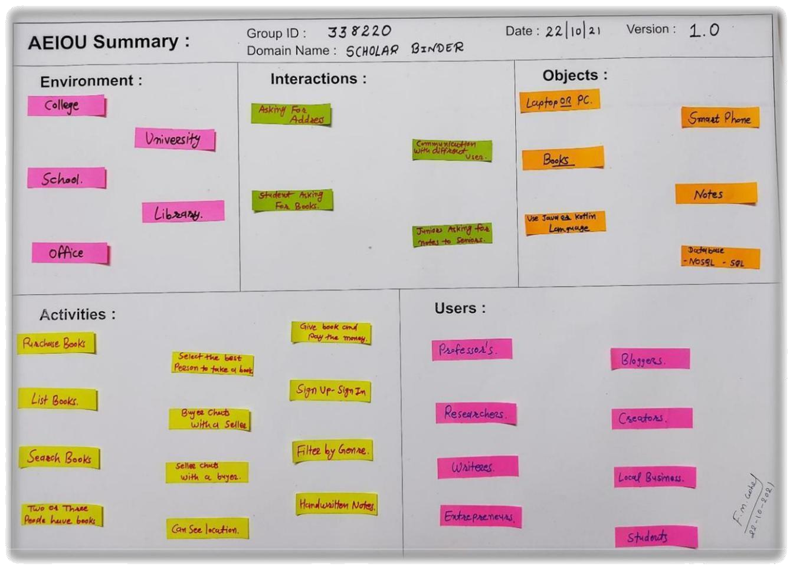

[FIG 2.1: AEIOU CANVAS]

We are making the system on the bases of environment like college, university, school, library and office. There are different kinds of interactions like asking for address, type of book, notes for junior communication with different-different users. We use objects like laptop/pc, smartphone, books, notes, digital materials.

Activities performing like purchase books, list books, filter by genre, handwritten notes, also can see location, seller buyer chat, sign-in/sign-up, login. Types of users using this web professor’s, bloggers, researchers, creators, writers, local business man, entrepreneurs, students, teacher etc.

### Ideation Canvas

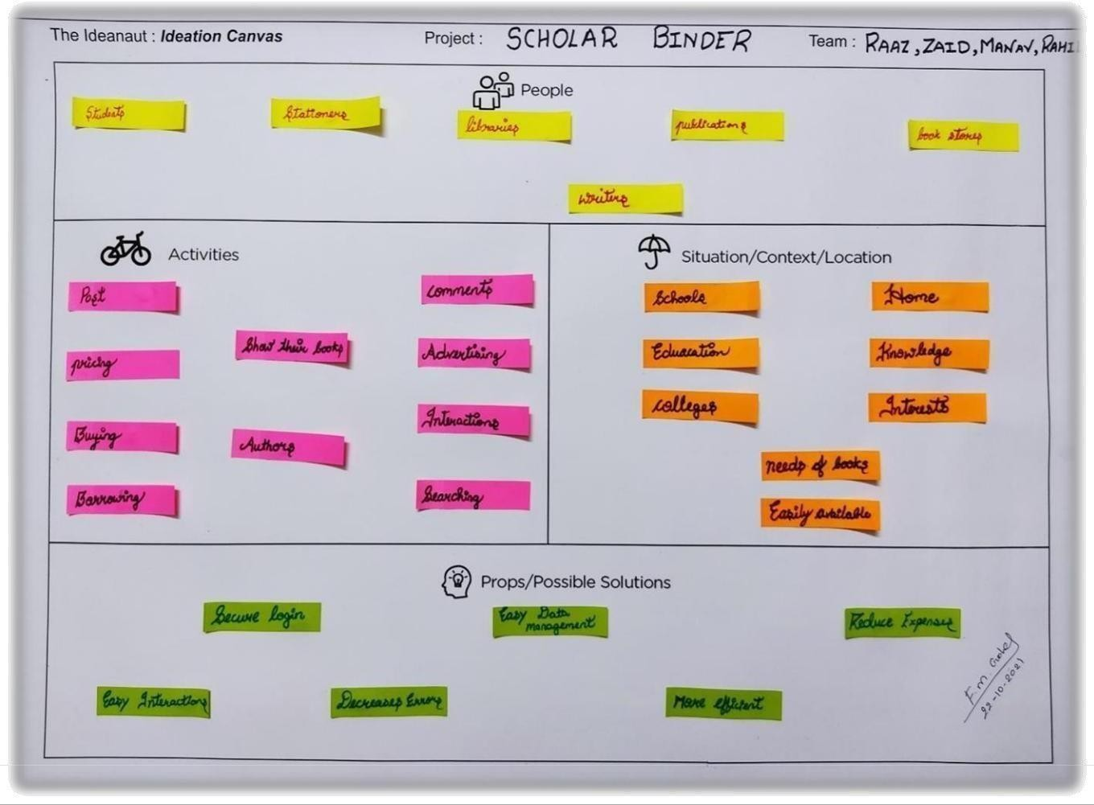

[FIG 2.2: IDEATION CANVAS]

People using our system in a very general term. There are different types of users the idea we are mentioning some of them students, librarian, publication, book store, writers etc. Activities like post a picture of books, pricing, buying-borrowing, authors, advertising, interactions, searching, filtering customers also get their information, location to easily get the detail information about the seller/buyer possible solution we are giving to the users are securely login, decreases errors, easy data management, more efficient, reduce expenses, easy interactions, more efficient.

### Empathy Mapping Canvas

[FIG 2.3.: EMPATHY MAPPING CANVAS]

There are different types of users like students, writers, teachers, vendors, librarian, business man. Stakeholders are colleges, stationaries, book store, libraries, coaching classes from this many location a buyer can search across the giving data set that he/she wants to which type of books or from near by location it is available or not. Activities login, sign-in, creating new account, location access, review and comments, chatting between seller/buyer. 6

### PRODUCT DEVELOPMENT CANVAS

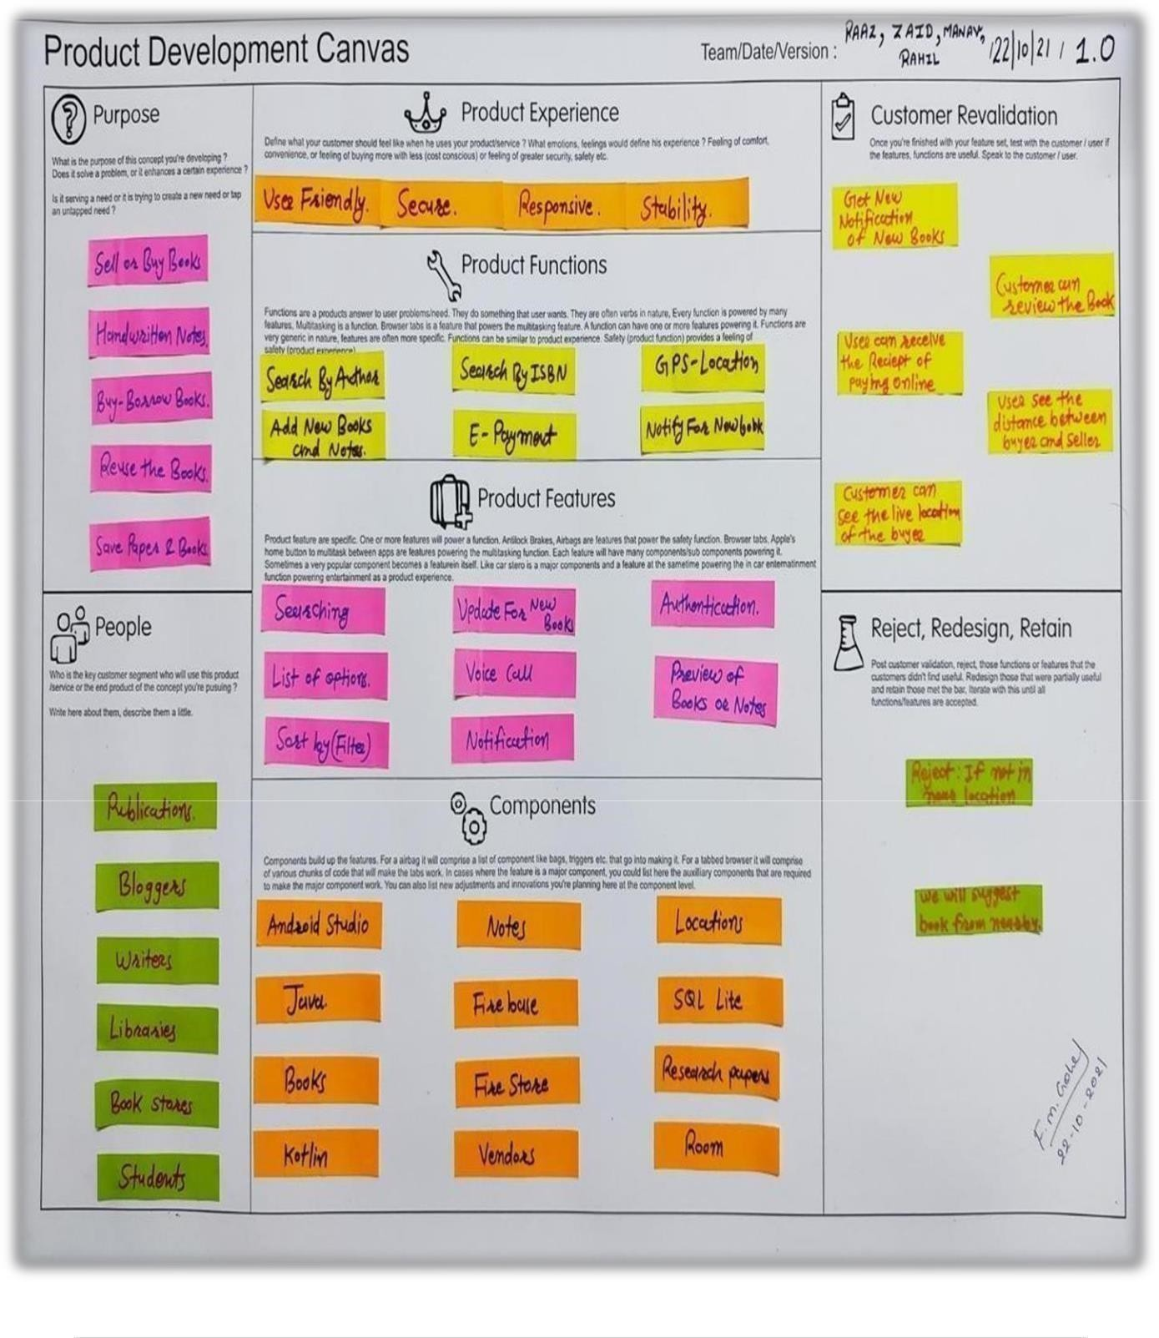

[FIG 2.4: PRODUCT DEVELOPMENT]

### MINDMAPPING CANVAS

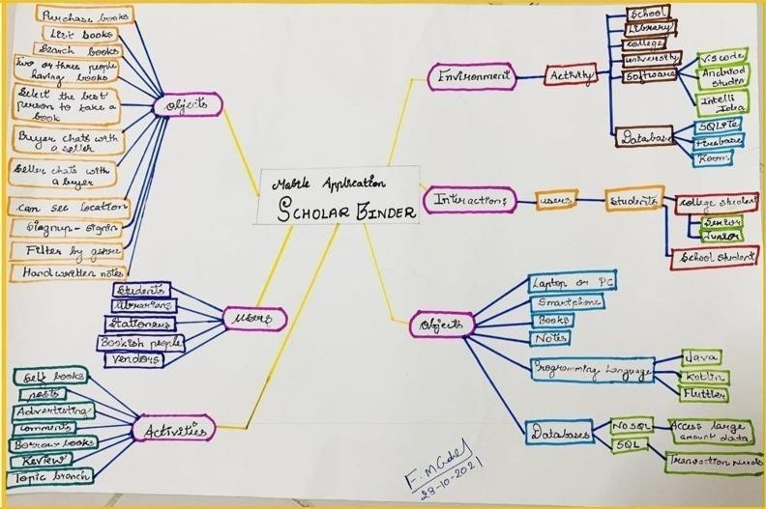

[FIG 2.5: MINDMAP]

### LEARNING NEEDS MATRIX

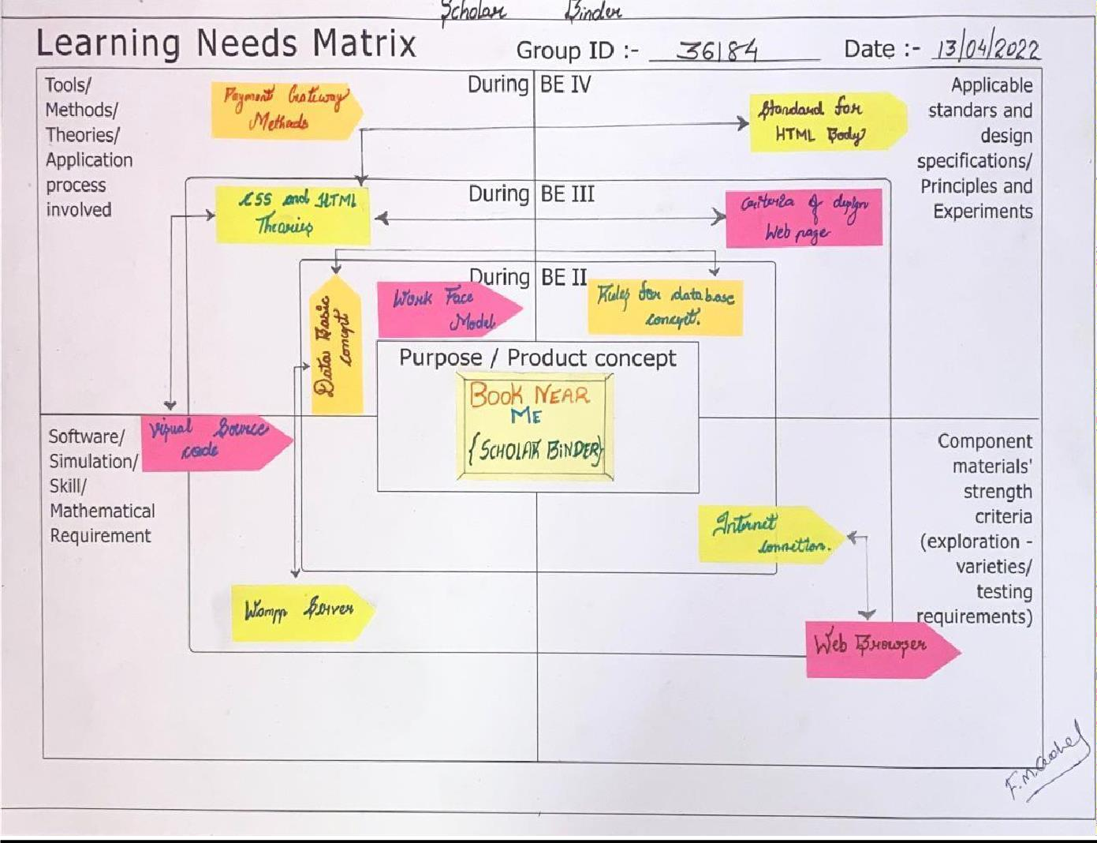

[ FIG 2.6.1 : LEARNING NEEDS MATRIX ]

### CHAPTER 3: FEEDBACK ANYALISIS

* 1. **:USER FEEDBACK**

In order to seek feedback of buyers and seller regarding our SCHOLAR BINDER, we visited different website and discussed about our software. In addition to positive feedback, the users also suggested some modifications to be done in our software. After thinking intensely on the users’ suggestions, We performed some modifications in the features of our software and also prepared a modified flowchart as our rough prototype.

User suggests following improvements that we have to done in our application:

* + 1. Feedback or Comment option.
    2. Easy payment methods.
    3. Retail books.

### VERSION 1.1

* + - * After confirming flow chart, we developed our system by using “PHP, HTML, CSS, and JAVASCRIPT”. This version is our final version now. We have made our system Responsive,used Validations and Database Connectivity. As our main motive is to develop a good platform to sell and buy books. Very first user have to login in the system if user is already registered then he/she can direct login to the system or else he/she has to register them first. After login user are able to see the page that includes the different tab provided in our site.
      * After selection of one tab user can see the features according to selection. For ex, you select book then it will display all the available book for rent or purchase. User can add that book toits cart and fill up the mandatory details. And proceed further to payment option where user has to add the delivery address and payment option, if user select online-payment then user has to give the bank detail. After a successful payment user will get a payment receipt.

##### Here we presented screenshots of prototype to display how it looks like:

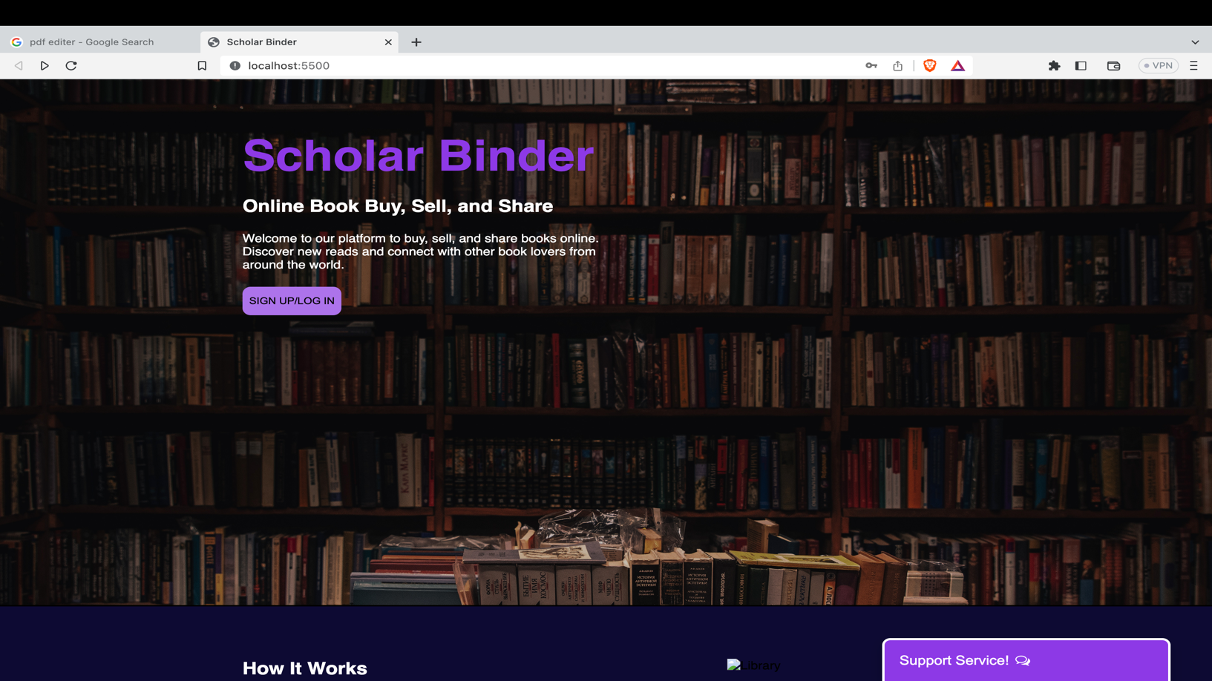

[FIG 3.1 FRONT INTERFACE]

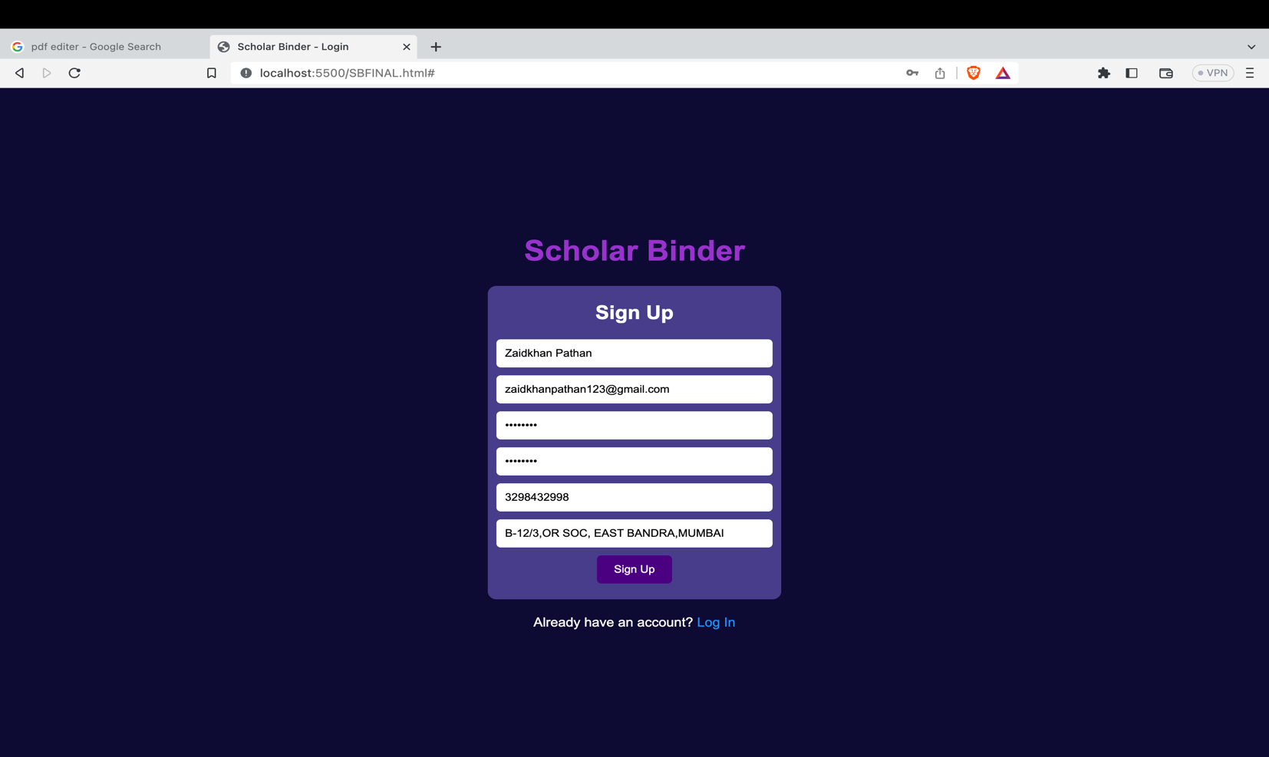

[FIG 3.2 SIGN UP]

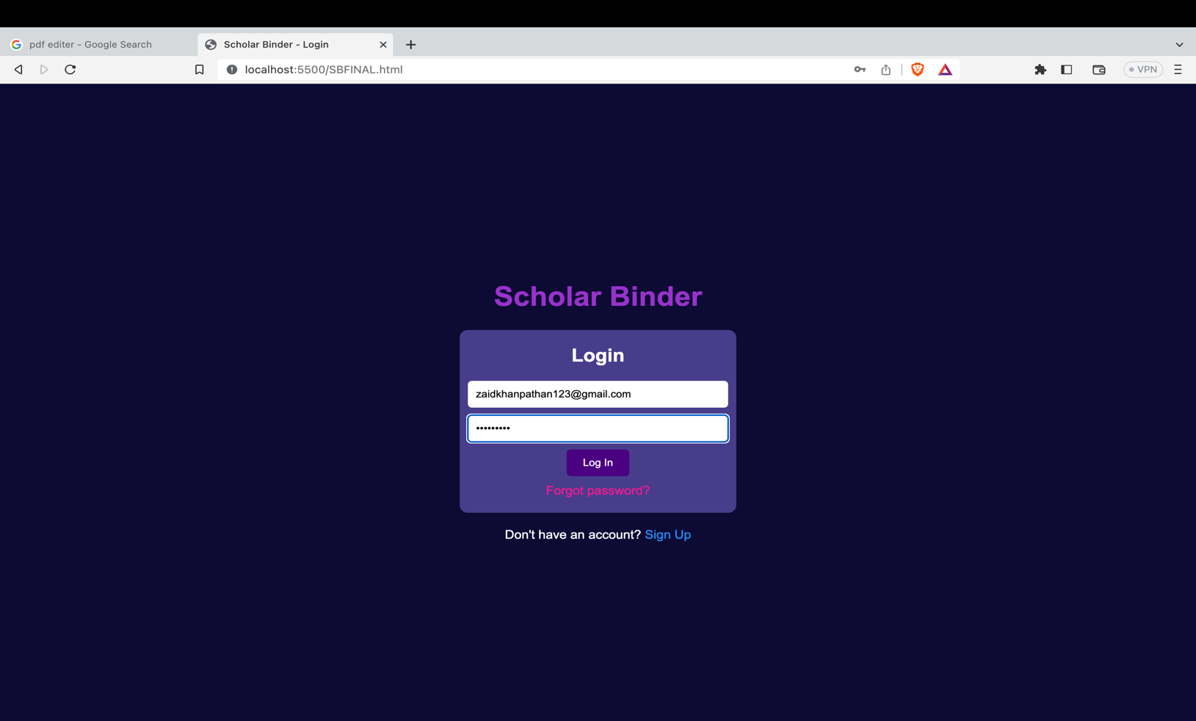

[FIG 3.3 LOG IN]

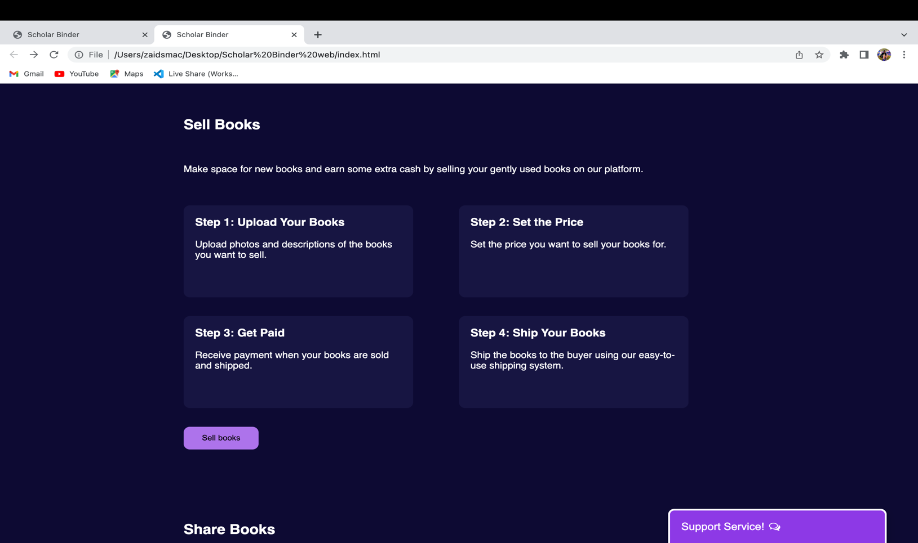

[FIG 3.4 SELL BOOKS]

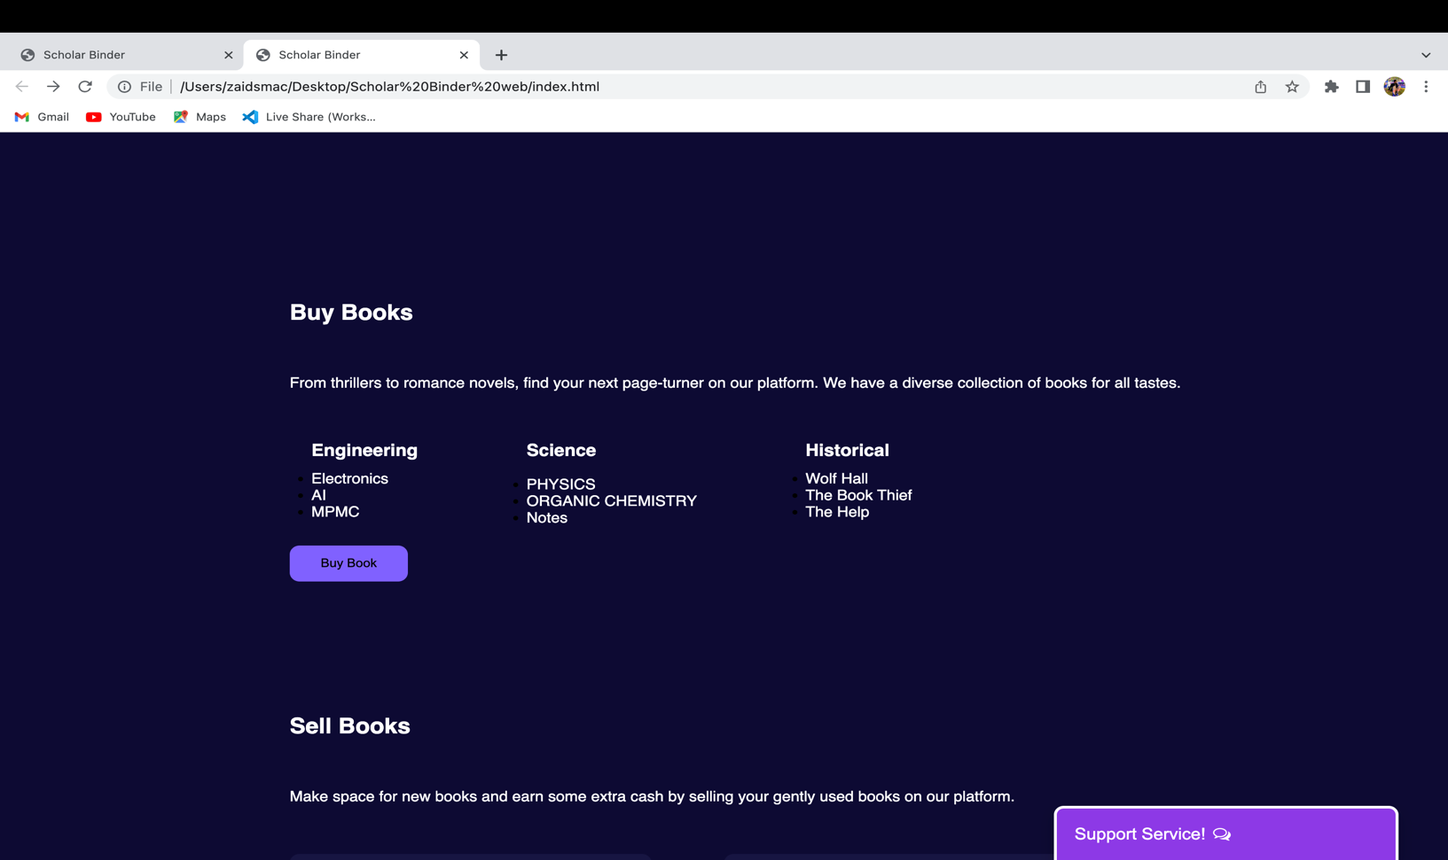

[FIG 3.5 BUY BOOKS]

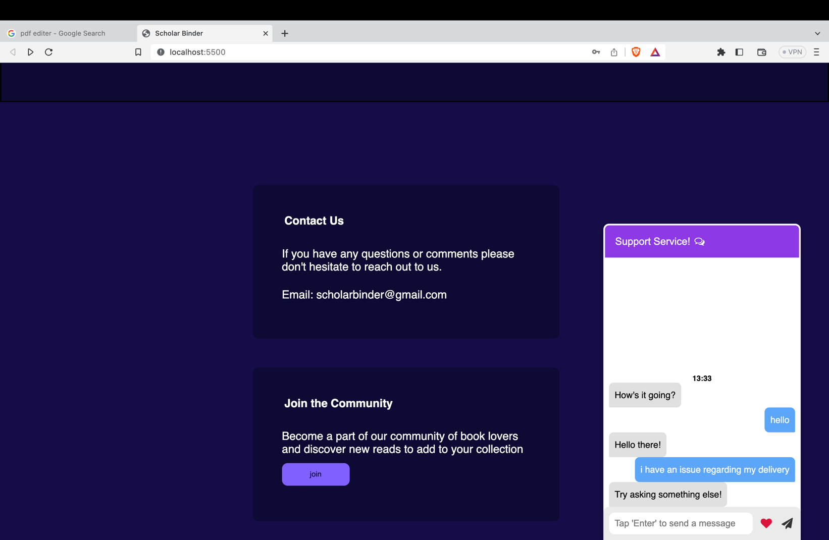

[FIG 3.5 SERVICE SUPPORT]

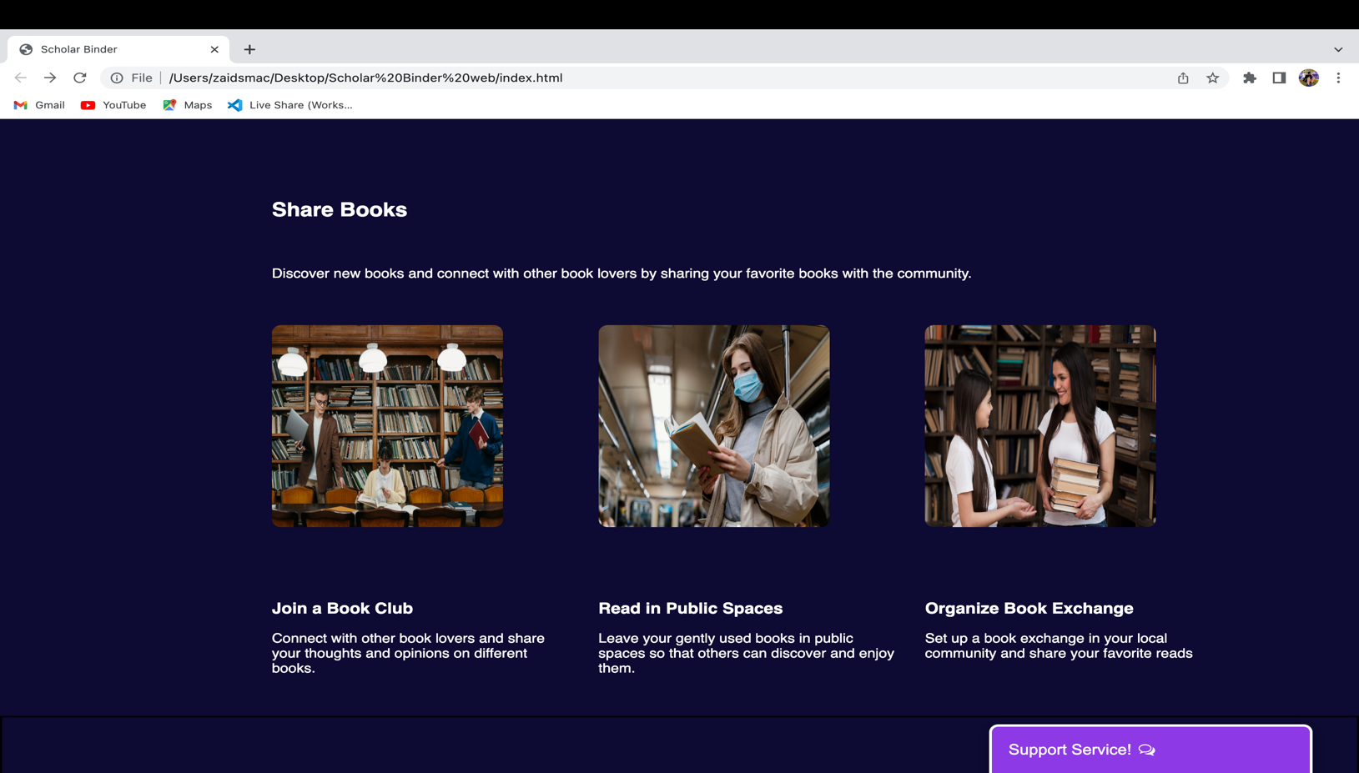

[FIG 3.6 SHARE BOOK]

### CHAPTER 4. DESIGN CALCULATIONS

##### DESIGNS FOR PERFORMANCE.

Performance, Safety and Reliability.

##### PERFORMANCE

Performance is an approach to the design of any complexity. An website is build in such way that it meets certain predictable performance requirements, such as efficient, fast and easy. users are able to view the design of an website they are just using that application by interacting with front-end. We will design an website in easy manner not complex. Otherwise, it decreases overall performance of the system. It must be design in such way that it should not be containdelay in communications. So, our website satisfies the feature of high performance.

##### SAFETY

Safety in application means it must be protected against viruses and other external attacks. The system should be protected from the bugs, virus and malwares as system should be protected by software such as firewall that prevents hazards and protects the system from being corrupted. There must be availability of backup in case of any inadequate condition. Features of safety also includes restriction in accessibility. An application must be contain restricted access from unauthorized users. Only authorized users can alter data of an application. Proper management of data should be there and also the protection to that data should be maximize in order to avoid the specific attacks. We also provide password protection in our website so that only authorize user can use website and unauthorized user cannot access data. In this way, our website satisfies safety feature.

##### RELIABILITY

Reliability is an attribute of any computer-based component that consistently performs according to its specifications. An application is user friendly and it is easy to operate and understand. Our application is only for android version. Any non-computer or computer users can easily use this application. The main aim of our application is sell/buy books in convince way.

##### DESIGNS FOR ERGONOMICS AND AESTHETICS.

Ergonomics means a science that deals with designing and arranging things so that people can use them easily and safely. Our website is user friendly so that any user can easily understandand use. Our website has simple format. That’s why any user who not uses such website can also use it correctly. To need any help, we also provide an option of contact us.

In this way, we provide easy communication between users. Aesthetics means study of how your website works in real life. It contains designs of working of a website.

##### DESIGN FOR COST AND ENVIRONMENT.

Today Computer & Network technologies are widely used many computer applications that are based on Internet. Buying and selling online are conducted through the internet. It is developed by using many languages. Also our system can be applicable in all types of environment regardless of any side effects.

##### MODELLING AND ANALYSIS USING SOFTWARE.

In our website, we created Class diagram and use case diagram for modeling and analysis of system.

**CHAPTER 5. CONCLUSION**

* This app will help student by not roaming here and there to buy or sell their books.
* User can easily get nearest seller/buyer and also get a better deal by chatting.
* Users will explore many books and get some reviews about those books that they want to buy.
* By this app many user will save their time by only on click to buy or sell.

#### REFERENCES

1. [https://www.olx.in](https://www.olx.in/)
2. [https://www.youtube.com](https://www.youtube.com/)
3. [https://www.programiz.com](https://www.programiz.com/)
4. [https://www.amazonkindle.com](https://www.amazonkindle.com/)
5. [https://www.calllibrary.com](https://www.calllibrary.com/)